1. **Design PDA using a simulator to accept the input string “aabb”.**

**AIM:**To design PDA using a simulator to accept the input string aabb.

**TRANSITION DIAGRAM:**

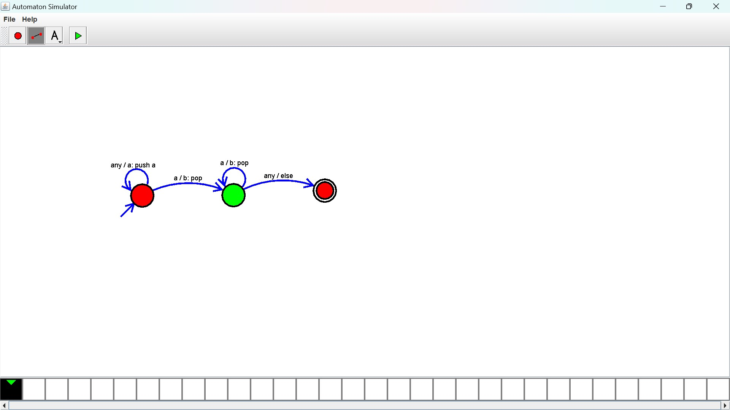

**RESULT:** The PDA is designed to compute the string given as input using a simulator.